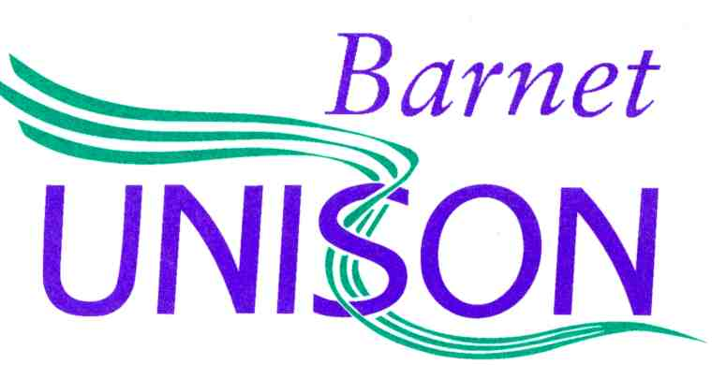
Barnet UNISON,
Room 1.9,
2 Bristol Avenue,
Colindale,
London
NW9 4EW

Telephone: 020 8359 2088
contactus@barnetunison.org.uk
www.barnetunison.me.uk

02 July 2024

Dear Social Work England

We are social workers from three mental health social care teams, employed by the London Borough of Barnet (LBB). These are the teams covering the North and South of the borough as well as the AMHP service. We understand that you are a body whose:

“purpose is to regulate social workers in England so that people receive the best possible support whenever they might need it in life. We are committed to raising standards through collaboration with everyone involved in social work.”

We are writing to you to bring to your attention the serious concerns regarding the safety of the mental health social care service, currently managed by registered social workers, which have resulted in the mental health social workers taking industrial action since September 2023. As of the date of this letter, staff have taken 74 days of industrial action.

Staff have been raising increasing concerns since the restructure to mental health social care, which took place approximately 2.5 years ago. The impact of the restructure is that the social workers have been pulled out of the community mental health teams and are no longer embedded within a multi-disciplinary team. This means that we do not have access to psychiatrists, psychologists, mental health nurses or mental health occupational therapists. The vast majority of the team do not have access to the person’s mental health record, which means it is not possible to appropriately assess or manage risks. Staff have continued to raise numerous and increasing concerns regarding the safety of the service. Unfortunately, LBB have not addressed the concerns raised, which has resulted in a mass exodus of staff and waitlists increasing to very concerning lengths for Care Act Assessment.

Mass exodus of staff
Including planned departures, approximately 29 mental health social workers will have left the service over the course of 22 months. This includes the vast majority of experienced workers. In one of these teams the figures demonstrate that when looking at the years of mental health experience, the team has lost over 80% of experience. The impact is that these teams are disproportionately comprised of social workers with very little, if any, mental health experience. This is particularly concerning given that despite numerous requests for appropriate training, a large number of staff have not had any mental health training, nor training of how to undertake s.117 aftercare assessments, which form a large part of our work. Our workers wonder how much this contributes to the fact that Barnet Enfield and Haringey NHS Trust has the “highest number of seven-day readmissions” in England (The Guardian, January 2024).

Risks to waiting lists and assessments.
The Local Government & Social Care Ombudsman’ consider it reasonable for a person to wait 4-6 weeks for an assessment. The impact of not addressing the concerns, alongside the substantial loss of experienced staff, has resulted in the waitlists for a Care Act Assessment from the mental health social care teams in Barnet increasing to up to 17 months. It should be stressed that these are not people with low level needs for whom it is safe to wait for an assessment. Without adequate support people with serious mental disorders are at significantly increased risk of deterioration to their mental state. Far too often our work becomes crisis management, which statutory guidance is clear cannot achieve wellbeing.

When people are left to deteriorate, unmanaged risks to their health and wellbeing put them at significant risk of harm, and even death, whilst awaiting an assessment. This is particularly concerning given that the people we work with have serious mental disorders and/or complex dementia, which already elevates risk. We further see this in complex presentations of self-neglect owing to deterioration to mental state. It is particularly concerning that people on our waitlist are deteriorating to such a degree that the risks to their health and wellbeing falls under the scope of safeguarding. This has caused us to ask the question: if they are at risk owing to us not meeting our statutory responsibilities to assess their needs and provide them with care and support – is Barnet Council not the perpetrator of the neglect?

Risks to reviews
The Care Act specifically states that reviews should be undertaken, at a minimum, of every 12 months. However, in Barnet mental health social care people are not receiving regular reviews in line with this statutory requirement. It is rare that we undertake reviews within this timeframe. Our recording system, Mosaic, shows evidence that many people have not had a review in several years, prior even to the existence of the mental health social care teams. There are some people whose packages of care have not been reviewed since 2019. Only those who contact social services to request a review are being added to the active waitlist, though they too join the up-to 17 months wait.

Risks to carers and families.
Many of the vulnerable people we work with do not have informal carers and their needs are simply going unmet whilst they await input. However, for those who do have informal carers, we have seen that the significant waitlists are placing high levels of stress on the carers, which is resulting in carer breakdown or carers not being able to engage in areas central to their own wellbeing, owing to increased pressure on their caring role.

Risks to staff
The remaining staff are desperately trying to plug the gaps and the result is a significant impact on staff’s own wellbeing, with staff reporting poorer physical and mental health. When surveyed, 100% of staff who responded stated they had considered leaving the service. Our colleagues who have left LBB have shared with us how their physical and mental wellbeing has improved through doing so. In an open letter to LBB asking them to resolve the dispute, one former staff member stated, “In the two months since I left LBB my mental health, physical health and work/life balance has improved”.

Importance of recruitment and retention payment.
Our social work colleagues in LBB’s Families Service face a similar recruitment and retention crisis which has been ongoing for several years. LBB has a recruitment and retention policy in place for such situations and this is being used to stabilise the Family Service social care workforce. Family Service social workers receive a recruitment and retention payment, paid at three different levels varying between 15%, 20% and 25%, depending on the severity of their recruitment and retention problems. We are therefore simply asking for this policy, already in place for social workers in Family services, to be equally applied to social workers in adults’ services. We have consistently demonstrated that we meet criteria for the policy to be applied and our view is that this will help stabilise our workforce in the same way it stabilises Family Services social care.

Social worker duty to report risk
The British Association of Social Workers sets out that social workers are expected to raise awareness where resources are inadequate. Furthermore, Social Work England, the regulatory body for social workers, sets out that social workers should raise concerns about unsafe practice and should challenge practices, systems, and processes where necessary. Unfortunately, LBB refuses to address the significant concerns and continues to dismiss the evidence that they are not providing a safe service for clients with mental ill-health. We see industrial action as a necessary extension of our responsibilities to advocate for those we serve and to take steps to protect them from harm and promote their wellbeing.

We would welcome the opportunity to meet with you and discuss these concerns in greater detail.

Please email our Barnet UNISON office at contactus@barnetunison.org.uk to arrange a time for us to meet with someone from Social Work England.

Yours sincerely

Barnet UNISON Mental Health Social Workers, London Borough of Barnet.

